**The U.S. Arts and Cultural Production Satellite Account (1998-2016): A National Summary**

*The Economic Impact of Arts and Culture Is on the Rise*

In 2016, production of arts and cultural commodities (i.e., goods and services) in the United States contributed **$804.2 billion, or 4.3 percent**, directly to the nation’s GDP—up from 4.2 percent in 2015. Also in 2016—the most recent year for which data are available—**over 5 million wage-and-salary workers** were employed to produce arts and cultural goods and services. Those workers were compensated $386 billion in 2016.

The arts contribute more to the U.S. economy than do construction, transportation and warehousing, or agriculture (among other sectors), and they generate a widening trade surplus. From 2006 to 2016, this surplus grew 12-fold, to nearly $25 billion.

Below are other summary findings from the 2016 Arts and Cultural Production Satellite Account (ACPSA). *Click on the topic to go directly to that section of the document*.

1. Value Added by Arts and Cultural Industries
2. Comparing Arts and Culture with Other Sectors of the Economy
3. Trends in Arts and Cultural Production
4. Workers Engaged in Arts and Cultural Production
5. Consumer Spending on Admissions to Performing Arts Events
6. Arts and Cultural Contributions to the Creative Economy
7. Exports of Arts and Cultural Goods and Services

# **I. Value Added by Arts and Cultural Industries**

1. In 2016, arts and cultural production contributed $804.2 billion to the U.S. economy.

* That production amounted to 4.3 percent of U.S. GDP, up from 4.2 percent in the previous year.

1. Six detailed industries emerge as top contributors to the total economic value added by arts and culture:

* Broadcasting (excluding sports); motion picture industries; publishing (excluding Internet); arts-related retail trade; “other information services” (an industry that includes Internet publishing and broadcasting/streaming); and performing arts companies and independent artists, writers, and performers.



1. Arts education accounted for over half (52.5%) of the total economic value of arts and cultural goods and services that federal, state, and local government produced in 2016.
   * In the table below, the term “educational services” denotes visual and performing arts education at *public* primary and secondary schools and colleges and universities.
     + Recent data from the ACPSA suggest that the provision of *all* school-based arts education (in both public and private schools) is stabilizing, after steadily falling throughout much of the 2000s.[1]
     + In 2016, production of school-based arts education (whether public *or* private) reached $111.2 billion, a level slightly greater than in 2015, after adjusting for inflation.[2]



# **II. Comparing Arts and Culture with Other Sectors of the Economy**

1. Arts and culture surpasses a number of other sectors such as construction, transportation and warehousing, and agriculture (including forestry, fishing, and hunting).[3]
   * Arts and cultural value added is nearly 5 times greater than that of the agricultural sector.
   * Arts and culture adds almost $60 billion more than construction and $227 billion more than transportation and warehousing to the U.S. economy.

# **III. Trends in Arts and Cultural Production**

1. The value added by arts and culture to GDP generally has risen throughout the 19-year period captured by the ACPSA.
   * Over the most recent three-year period (2014-2016), the *average annual growth rate* of real value added by arts and culture was 4.16 percent, nearly double the 2.22 percent growth rate generated by the total U.S. economy.[4]
2. The fastest-growing industries producing arts and cultural goods and services include sound recording, “other information services” (e.g., Internet publishing and broadcasting/streaming), rental and leasing of costumes and arts-related equipment, and architectural services.
   * Arts and cultural value added by sound recording and by “other information services” both grew by an annual average rate of approximately 18 percent between 2014 and 2016.[5]
   * Value added by arts-related rental and leasing establishments (such as those that lease theatrical wardrobes and equipment) grew by 9.7 percent over the three-year period.
   * Architectural services expanded by 5.8 percent.

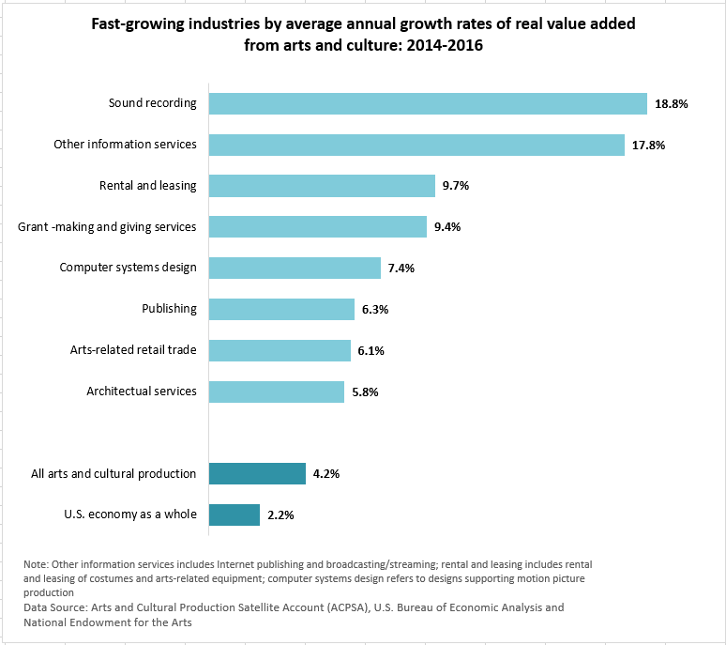

# **IV. Workers Engaged in Arts and Cultural Production**

1. In 2016, the arts and cultural sector employed more than 5 million wage-and-salary workers.
   * Compensation for those workers topped $386 billion that year.
2. The number of workers employed to produce arts and cultural goods and services has risen in recent years.
   * Following the Great Recession, between 2009 and 2016, the arts and cultural economy added 206,000 workers.



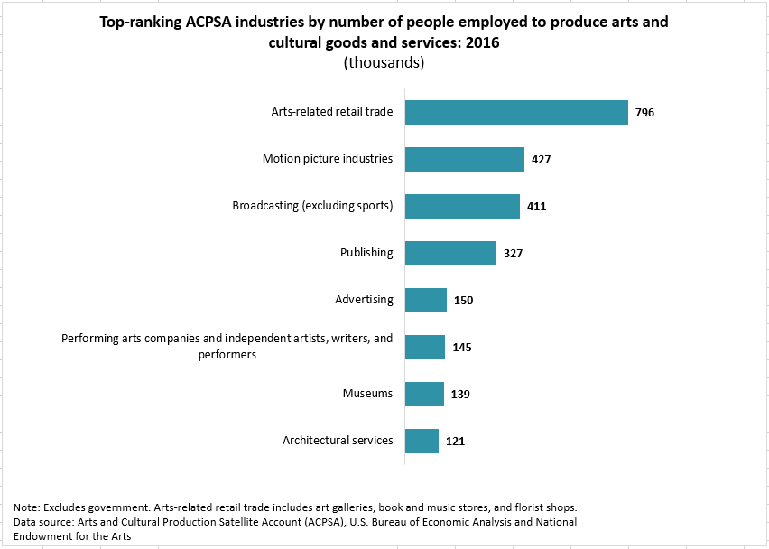

# **V. Consumer Spending on Admissions to Performing Arts Events**

1. In 2016, U.S. consumers spent $32.7 billion on admissions to performing arts events.



1. Since 1998, consumer spending on admissions to the performing arts, as a share of all U.S. consumer spending, has more than doubled.
   * Consumer spending on tickets to performing arts events rose from 0.12 percent of all U. S. personal consumer spending in 1998 to 0.26 percent in 2016.

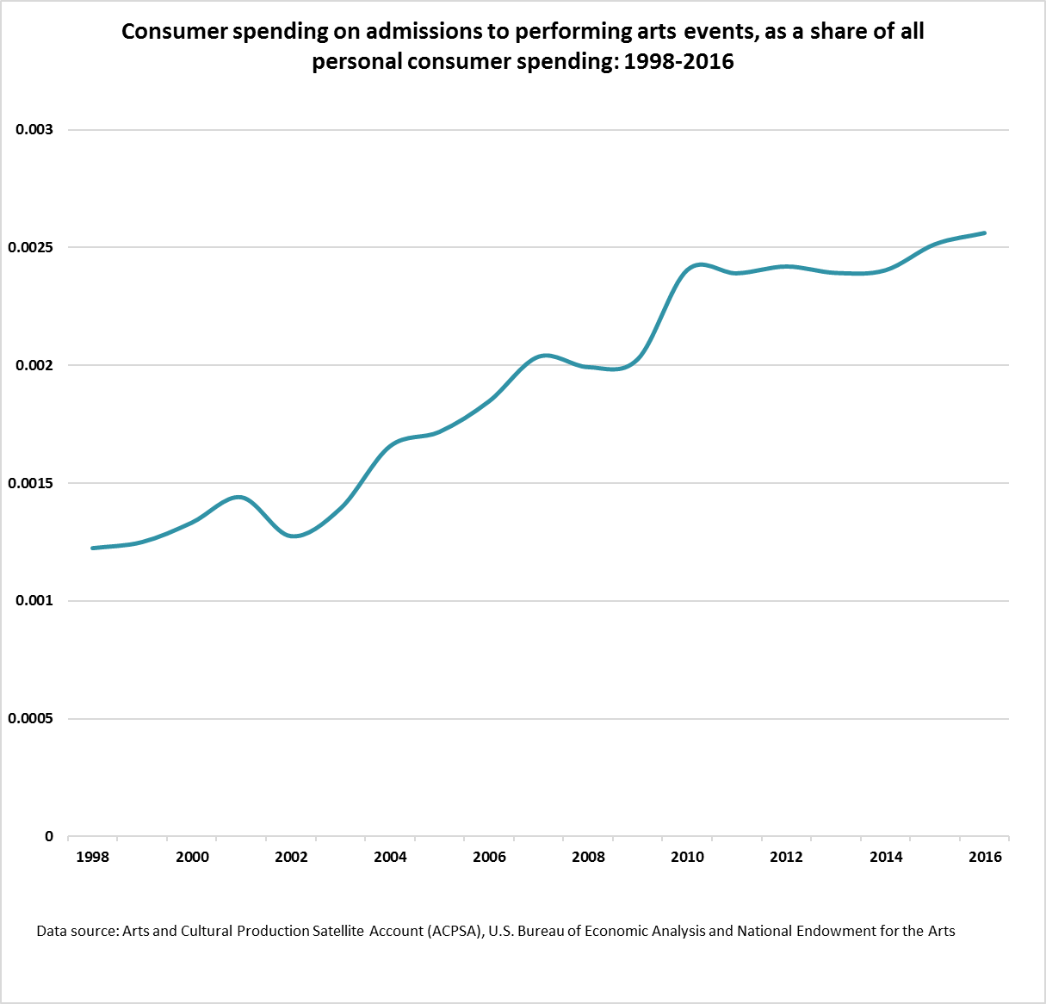

# **VI. Arts and Cultural Contributions to the Creative Economy**

1. Arts and cultural production accounts for roughly half of the U.S. “creative economy.”
   * In 2016, copyright-intensive industries contributed $1 trillion to the U.S. economy. Of that value, nearly $500 billion stemmed from the production of arts and cultural goods and services. [6]
2. Between 2014 and 2016, average annual growth in production of copyright-intensive arts and cultural goods and services grew 5.6 percent.
   * + Average annual growth in production was particularly strong for: sound recording; “other information services” (which includes Internet publishing and broadcasting/streaming); arts-related computer systems design (supporting motion picture production and sound recordings); and publishing (which includes arts-related software publishing).





# **VII. Exports of Arts and Cultural Goods and Services**

1. The U.S. exports more arts and cultural goods and services than it imports, resulting in a trade surplus.
   * In 2016, the U.S. exported nearly $25 billion more in arts and cultural goods and services than it imported.
   * The arts and cultural trade surplus has increased since 2006, when it was $2 billion.
2. ACPSA exports are driven by movies and TV programs, advertising, arts-related software (e.g., video games), and jewelry and silverware.
   * In 2016, those commodities accounted for $44.2 billion, or nearly 68 percent of all ACPSA exports.
   * Other notable U.S. exports of arts and cultural goods and services include sound recording (which generated $2.8 billion in exports in 2016) and works by performing arts companies and independent artists, writers, and entertainers (generating $1.5 billion in U.S. exports).

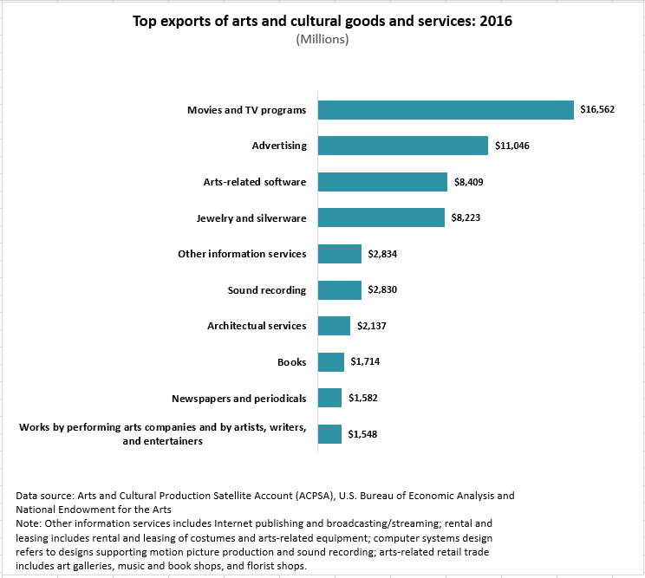

**A Postscript: Arts and Cultural Production as Investment**

Historically, private fixed assets were in the form of physical capital (i.e., plant and equipment assets). In more recent years, however, the BEA has expanded its definition of investment to include the capitalization of intangible assets.

For example, software development was first counted as fixed private investment in 1999. And in 2013, the national income and product accounts (NIPAs) were revised to include research and development expenditures as investment.

Also in 2013 was the BEA revision that capitalized “entertainment originals.” Entertainment originals refer to theatrical movies; long‐lived television programs; books; music; and other “miscellaneous entertainment” such as scripts and scores for the performing arts, greeting card designs, and stock photography.

In 2014, for example, investment in entertainment originals was **$72 billion**. In 2016, that investment rose to nearly **$81 billion.** During this period, and after adjusting for inflation, average annual growth for this type of capital investment was 10.7 percent.

1. “School-based” refers to primary, secondary, and post-secondary arts education.
2. See *U.S. Arts and Cultural Production Satellite Account: Issue Brief #4, Trends in U.S. Arts Education (1998-2013)*.

   Stability in the provision of arts education reported for 2016 coincides with real growth in state government expenditures on education. According to estimates published by the U.S. Census Bureau, between 2015 and 2016, state government outlays on education grew by 6.2 percent. Over the same period, the Bureau of Economic Analysis reports that inflation, measured by the personal consumption expenditures index (excluding food and energy), grew by less than 2 percent; BEA’s price index for state and local government expenditures and gross investment showed no change between 2015 and 2016.

   It remains unclear how and whether the Every Student Succeeds Act may have contributed to stability in arts education, as reflected in the Arts and Cultural Production Satellite Account. The law, which gives a greater role to states for school accountability, and which includes the arts in its definition of a “well-rounded education,” was enacted only in December 2015.
3. The sectors given below are not mutually exclusive. For example, arts and cultural production includes parts of the construction sector—namely, the building of new arts and cultural facilities—and travel and tourism includes related performing‐arts spending.
4. “Real” ACPSA estimates are measured in 2009 chained dollars. For more information, see the BEA’s definition of [“chained dollar estimates.”](https://www.bea.gov/national/pdf/glossary.pdf)
5. According to the Census Bureau’s Services Annual Survey, revenue grew by 8 percent for “integrated record production/distribution,” an industry comprising establishments that release, promote, and distribute sound recordings. Revenue reported for music publishers grew 3.9 percent. In addition, non-employment revenue for sound recording increased by 2.7 percent between 2015 and 2016. (Non-employers are businesses with no paid employees and are subject to federal income tax.)
6. The NEA’s Office of Research & Analysis defines the “creative economy” as value added by industries that the U.S. Patent and Trademark Office has identified as copyright-intensive. See *Intellectual Property and the U.S. Economy: 2016 Update,* Economics & Statistics Administration and U.S. Patent and Trademark Office.