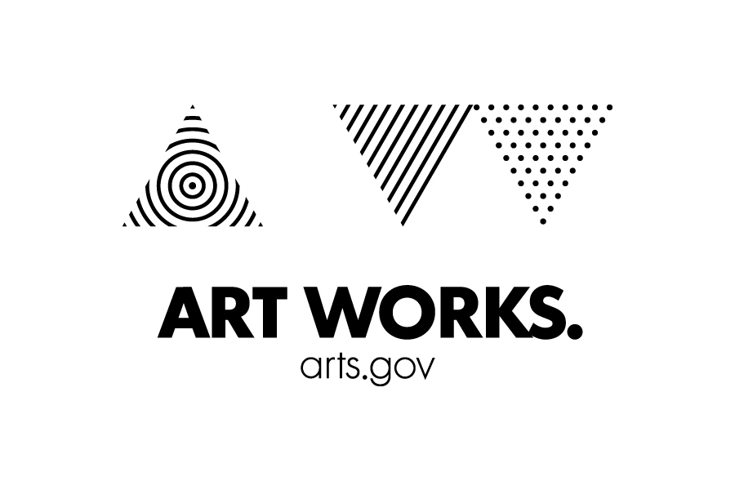
National Endowment for the Arts

Tell Us Your Story – Minor Permissions Form

On behalf of my minor child, ____________________________________________, I hereby grant the National Endowment for the Arts (“NEA”) a non-exclusive, royalty-free, irrevocable license to reproduce any text, image, photograph, digital, video or audio recording that I or my minor child may upload at http://arts.gov/tell-us-your-story or otherwise provide to the NEA (the "Submission Materials") in conjunction with the NEA's 50th Anniversary and other programs.

I agree that the NEA and its assignees and designees may use all or portions of the Submission Materials to raise awareness about the NEA's 50th Anniversary, NEA programs or to educate Americans about an art form or a particular artist in any of the following ways:

- Audio CDs. The NEA may include the Submission Materials in an audio CD that is created by the NEA or an NEA contractor.
- The Internet. The NEA may utilize the Submission Materials in video, audio, photo, and/or text format in streaming and/or downloadable format on its website (www.arts.gov), in electronic mailings, in electronic/web media including social media, and/or in podcasts and blogs.
- Radio. The NEA may use the Submission Materials on commercial radio stations, public radio stations, Internet radio stations, and satellite radio channels.
- Television. The NEA may utilize the Submission Materials in television segments or programs to be aired on local, public, cable, satellite, and/or digital television.
- Video/DVD. The NEA may utilize the Submission Materials in a VHS or DVD to be distributed for free as a public service announcement or educational video.
- Print publications. The NEA may use the Submission Materials in print materials.
- Successor technologies. The NEA may utilize the Submission Materials in subsequently developed technologies and the Submission Materials may be archived digitally or in any tangible form.

I recognize that this license includes worldwide rights by both myself and my minor child to the NEA or the NEA's assignee or designee. I release the NEA, and its assignees and designees, from any and all claims and demands arising out of or in connection with the use of the Submission Materials. By giving my permission, I understand that neither I nor my minor child give up any copyright or performance rights that we may hold.

I certify that I am the parent or legal guardian of the minor child and have the right to agree to the above, and that I am at least 18 years of age.

Accepted and agreed:

__________________________________________ _________________________________________
Signature of Participant Signature of Parent / Guardian

__________________________________________ _________________________________________
Print Name Print Name

__________________________________________ _________________________________________
Date Address

_________________________________________ _________________________________________
E-mail Phone

